SSA463
Handheld Spectrum
Analyzer Host Computer
manual

Version: V1.0.0 Date
: April 10 , 2026
Hangzhou SYSJOINT Information Technology Co.
, Ltd.

Table of contents
1. Software Introduction 1
1.1 Software Use 1
1.2 Software Features 1
2. user interface 2
2.1 Module division 2
2.2 Function Introduction 2
2.3 Top status bar 3
2.3.1 system 3
2.3.2 view 3
2.3.3 help 4
2.4 Bottom status bar 5
2.4.1 Connection status 5
2.4.2 Data transmission status 5
2.4.3 Display points 5
2.4.4 Transmission progress 5
2.5 Top Information Bar 6
2.5.1 Input bar 6
2.5.2 legend 6
2.6 View area 7
2.6.1 Spectrum 7
2.6.2 Waterfall picture 8
2.6.3 Bottom Information Area 9
2.7 Menu button 10
3. Menu function 11
3.1 Frequency sweeping method 11
3.2 trigger 12
3.3 Measurement 13
3.4 frequency 14
3.5 Detection method 15
3.6 Reset 15
3.7 RBW 16
3.8 mark 17
3.8.1 Select tag 17
3.8.2 conventional 17
3.8.3 Difference 18
3.8.4 closure 18
3.8.5 Close all 18
3.8.6 Set as center frequency 18
3.8.7 Set as starting frequency 18
3.8.8 Set to stop frequency 18
3.8.9 Set frequency 18
3.8.10 Related traces 18
3.9 Peak Search 20
3.10 peak 21
3.11 Scan points 21
3.12 Data export 23
3.13 Data import 24
3.14 trace 25
3.14.1 Average trace 26
3.14.2 Smoothing function 26
3.14.3 Reference trace 26
3.15 color 27
3.16 amplitude 27
3.16.1 Y-axis units 28
3.17 language 28
3.18 screenshot 29
3.18.1 The whole scene 29
3.18.2 Top Information 29
3.18.3 Spectrum 30
3.18.4 Waterfall picture 30
3.18.5 Text information area 31
3.18.6 Screenshot export format 31
3.19 Resize window 32
4. Quick Use 33
4.1 Run the software 33
4.2 Connecting devices 34
4.2.1 Connection failed 35
4.3 Set frequency 35
4.4 Set the detection method 36
4.5 Set RBW 36
4.6 Set points 37
4.7 Use tags 38
4.8 Enable marking 38
4.8.1 Function 38
4.8.2 Related traces 39
4.9 Peak Search 39
4.9.1 Continuous peak 40
4.9.2 Common functions 40
4.9.3 Set additional conditions for peak values 40
4.10 Level trigger 40
4.11 Measurement 42
4.11.1 Turn on or off 42
4.11.2 Change range 42
4.11.3 Results Display 42
4.12 Use other traces 43
4.12.1 Turn on or off 43
4.12.2 Average trace 43
4.12.3 Reference trace 44
4.12.4 Clear reference traces 44
4.13 Color selection 44
4.14 amplitude 46
4.15 Data import 47
4.16 Data export 47
4.17 Switch language 48

Software Introduction

Software Use
As the PC host computer for the SSA463 spectrum analyzer, it is used to connect to the SSA463 handheld spectrum analyzer , display real-time spectrum, waterfall chart , and import/export data .

Software Features
1. Quick device connection: When the connection function is activated, this software will automatically connect to available SSA463 devices without the need for manual selection of serial port, etc.
2. Real-time data display includes "real-time trace", "maximum hold", "minimum hold", "average trace", and "reference trace". The trace colors can be freely defined, and the "reference trace" can be freely named.
3. Waterfall chart display allows for free definition of zone colors.
4. Quickly modify the frequency, number of points, detection method, resolution, and bandwidth of the connected device.
5. Data export and import: It can simultaneously save "real-time trace", "maximum hold", "minimum hold" and "average trace", and can import up to 10 "reference traces".
6. Supports multi-window view, allowing selection of a local area of the spectrogram, drawing in an additional extended window, and synchronously displaying all traces of the selected area in the main window.
7. Channel power measurement allows you to freely select a region and calculate the power of the corresponding section.
8. Mark markers: Up to 10 marks can be displayed at the same time. You can long press or move them using the left and right keys.
9. Information bar display: The information bar at the bottom of the software records frequently used information, tags, etc. Clicking on it will quickly take you to the corresponding menu.

user interface

Module division
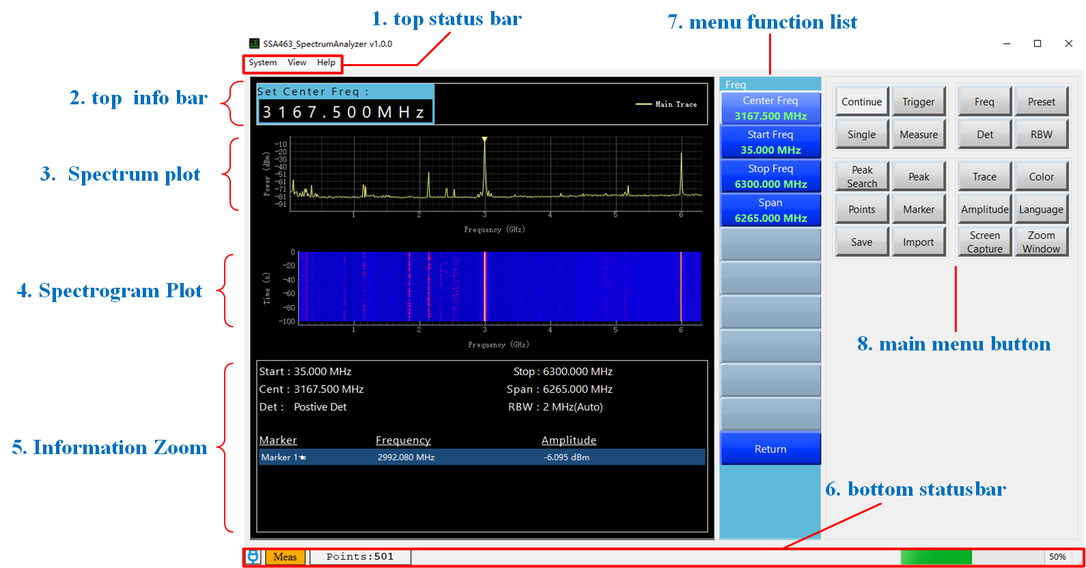
Figure user interface​1

Function Introduction
serial number | name | Function Description
1 | Top status bar | Quick functions, control device connection, and whether the view is displayed, etc.
2 | Top Information Bar | Display input information box and trace legend.
3 | Spectrum | Plotting the spectrum
4 | Waterfall picture | Draw a waterfall diagram
5 | Information display area | Quickly display settings and calculation information such as markers, frequency, detection method, and channel power.
6 | Bottom status bar | Displays the current software running status, points, and data packet transmission status.
7 | Menu function list | Display sub-functions of the main menu
8 | Menu button | The function module can be accessed by pressing it; more settings can be viewed in the function list.

Top status bar

system
Option Name | Main uses and scenarios
Connecting devices | Connect or disconnect the device. When you click "Connect Device," the software will automatically search for available SSA463 model devices and establish a connection, without requiring manual selection.
quit | Close this software
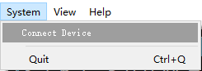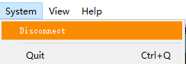
Figure user interface​2

view
Option Name | Main uses and scenarios
crosshairs | Once enabled, a crosshair will be generated in the spectrum area to aid in viewing.
Waterfall picture | Control whether to display the waterfall chart
Information bar | Displays start and end frequencies, detection method, RBW, and marker point information.
Waterfall settings | Set the color mapping for the waterfall chart.
The ✅ sign before the corresponding option indicates that the function is enabled.
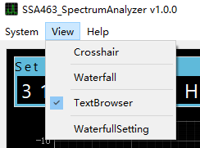
Figure user interface​3

help
Official technical support and version number for this software can be obtained.
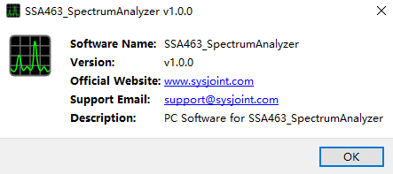
Figure user interface​4

Bottom status bar
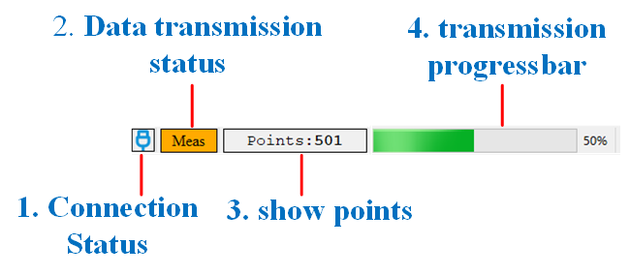
Figure user interface​5

Connection status
This indicates that the software is not connected to a device.
This indicates that the software has connected to the SSA463 device.

Data transmission status
This indicates that the software and device are transmitting data.
This indicates that the software and device are not transmitting data. In this case, the software may be in single-mode or not working properly.

Display points
Displays the current number of scan points on the device in real time.

Transmission progress
This indicates the data transmission progress of a frame. Due to modifications to RBW and the detection method, data acquisition may be more time-consuming. For better viewing, a frame of data needs to be transmitted in batches.
This indicates that the current transmission has timed out or transmission is not enabled.

Top Information Bar
Figure user interface​6
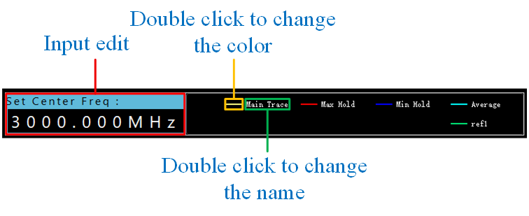
Figure user interface​7

Input bar
As shown in Figure 2-6, the input field is normally hidden and only appears when the selected function or parameter can be changed. No mouse click is required when inputting; the software will automatically capture keyboard input. Frequency-related data is in Hz by default, but reference units (H (Hz), K (kHz), M (MHz), G (GHz, case-insensitive)) are available. Pressing Enter or entering a unit signifies completion of the input and that the changes have been applied.

legend
As shown in Figure 2-7, the legend represents the trace currently displayed on the image. Double-clicking the legend's color area will change the corresponding trace color, and double-clicking the legend's name will change the trace name .
Note: The four commonly used traces—main trace, maximum hold trace, minimum hold trace, and average trace—cannot be renamed.

View area

Spectrum
(1) Scaling
1. To prevent accidental activation of the corresponding functions, this software abandons the rectangular selection box scaling and instead uses the mouse wheel to scale the X-axis and Ctrl + mouse wheel to scale the Y-axis.
2. The button in the lower left corner can automatically set the X and Y axes to automatic tracking mode. In this mode, the X and Y axes will continuously change to the minimum visible area of the image.
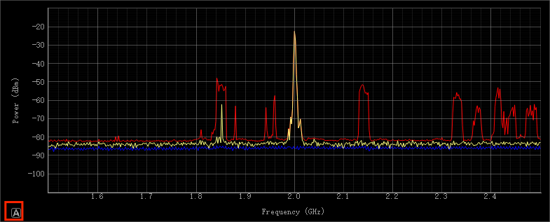
Figure user interface​8
(2) Right-click to bring up the menu
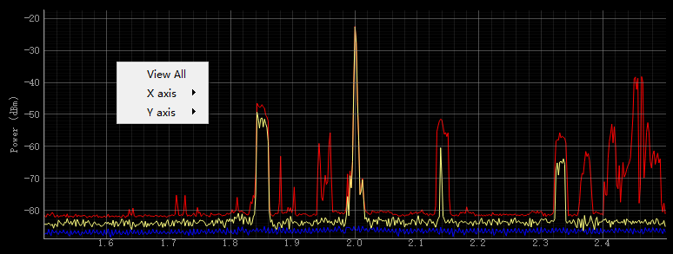
Figure user interface​9
Menu Name | Functions and typical application scenarios
View All | Clicking this will set the current X and Y axes to the minimum display area of the image, often used to quickly display the main view after zooming.
X axis | Once inside, you can manually set the X-axis range or set the X-axis range to automatic tracking.
Y axis | After entering, manually set the Y-axis range or set the Y-axis range to automatic tracking.

Waterfall picture
The waterfall chart stores 100 sets of historical data by default. The X-axis is synchronized with the spectrum chart. Modifying the waterfall chart will change the X-axis spectrum chart accordingly, and vice versa. Other functions are the same as the spectrum chart.
The color mapping of the spectrum can be set in "Top Information Bar" -> "View" -> "Waterfall Chart Settings" as shown in Figure 2-11.
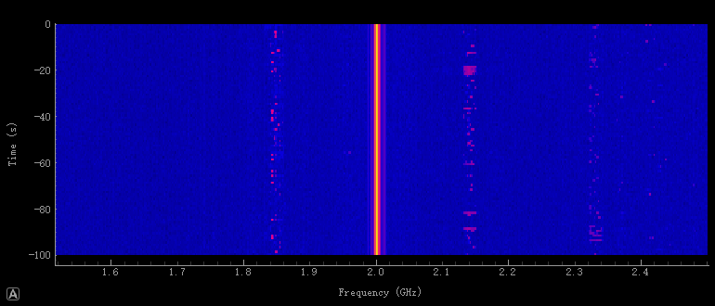
Figure user interface​10
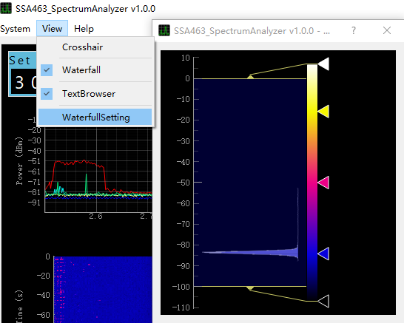
Figure user interface​11

Bottom Information Area
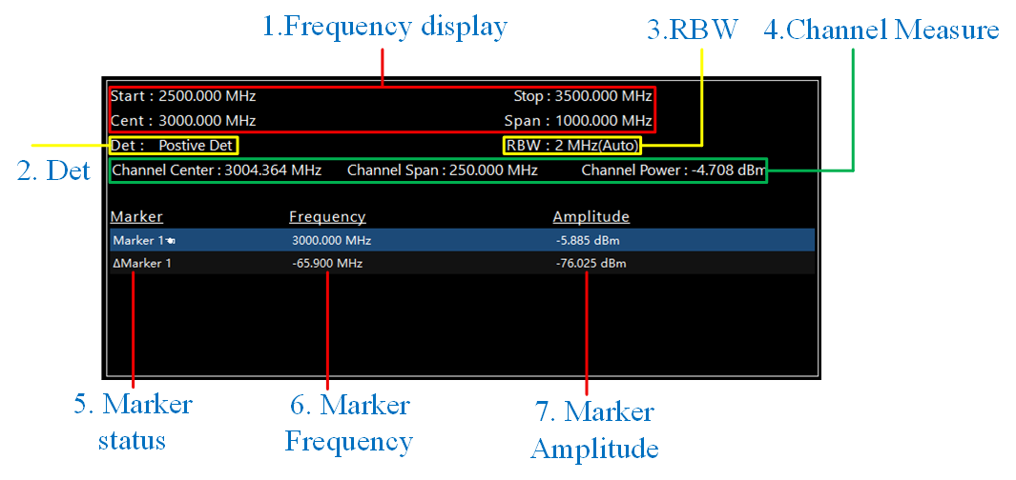
Figure user interface​12
As shown in Figure 11,
Field Name | meaning
1. Frequency display | Displays information such as the frequency range of the current spectrum graph.
2. Det | This displays the detection method actually used in the current spectrum diagram.
3.RBW | Displays the actual RBW resolution bandwidth of the current spectrum.
4.Channel Measurement | Displays the measurement range of channel power and the calculated power value.
5. Marking the state | Displays the current marker number and status. When the marker is in delta mode, a Δ marker is added before the number. When the "Continue Peak" function is enabled, the words "[continue peak]" are added after the marker. A hand icon after the marker and the entire line are highlighted to indicate the currently selected marker. The selected marker can be moved by dragging the mouse or using the left and right arrow keys on the keyboard.
6. Frequency | Displays the frequency of the same row marker. If the marker status is preceded by the word "delta", the data means the relative frequency difference in delta mode.
7. Amplitude | Displays the reference amplitude of the peer marker. If the word "delta" is preceding the marker status, the data means the relative amplitude difference in delta mode.
Note: Clicking on the corresponding field will redirect you to the relevant settings menu.

Menu button
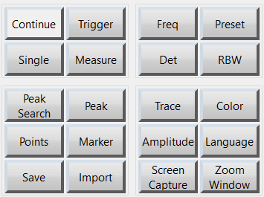
Figure user interface​13
Pressing this button will switch the menu sub-options, allowing you to view more related functions.

Menu function

Frequency sweeping method
Frequency sweeping is the core function of a spectrum analyzer, referring to the process by which the instrument, under the control of the local oscillator, sweeps from a starting frequency to a final frequency, completing one full spectrum measurement. Properly setting the sweeping parameters directly determines the measurement speed, accuracy, and the ability to capture a signal.
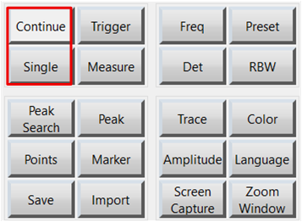
Figure Menu function​14

trigger
Button Name | Function Introduction
trigger | The button displays the activation status of the trigger function. When enabled, the lower part of the button shows a highlighted green "ON"; when disabled, it shows a highlighted red "OFF". Clicking toggles the status. When enabled, the spectrogram interface displays a highlighted yellow horizontal line with the relative amplitude displayed in the lower left corner. This horizontal line can be dragged freely. Clicking the horizontal line will quickly jump to the "Trigger" menu and pop up an input box for modification. When a frame of the spectrogram contains data with an amplitude greater than or equal to this value, the image freezes and the trigger function is disabled.
Trigger amplitude | After clicking, you can modify the trigger relative value in the top information area. At the same time, the current trigger relative amplitude is saved in the lower part of the button, as shown in the upper left corner of Figure 3-2.
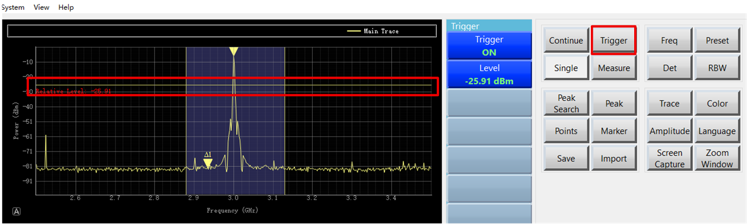
Figure Menu function​15

Measurement
Button Name | Function
Channel power | The display shows the power status of the display channel. It is indicated by a green highlighted "ON" when enabled and a red highlighted "OFF" when disabled. Clicking toggles the enabled state. When enabled, a purple rectangular area will appear on the drawing interface, which can be dragged freely as a whole or along one side .
Channel center frequency | Displays the center frequency of the channel power measurement range. After clicking, an input box will appear in the information bar above, as shown in Figure 3-3, which can be set according to needs.
Channel sweeping width | The scan width of the channel power measurement range is displayed . After clicking, an input box will appear in the information bar at the top, as shown in Figure 3-3, which can be set according to needs.
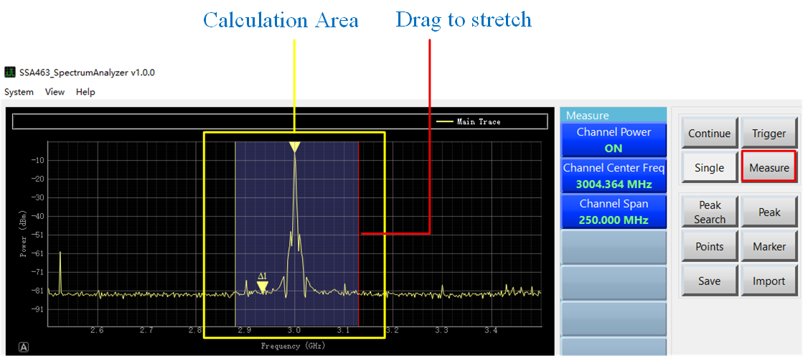
Figure Menu function​16

frequency
Clicking the "Frequency" button switches the function list, and an input box appears above the spectrum graph area. Sub-options allow you to set the "Center Frequency," "Start Frequency," "End Frequency," and "Sweep Width." No mouse clicks are needed in the input box; the software automatically captures keyboard input. Frequency-related data is displayed in Hz by default, but reference units (H (Hz), K (kHz), M (MHz), G (GHz, case-insensitive)) are available. Pressing Enter or entering a unit completes the input and applies the changes.
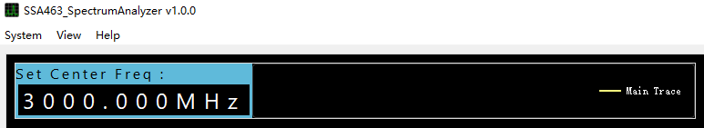
Figure Menu function​17
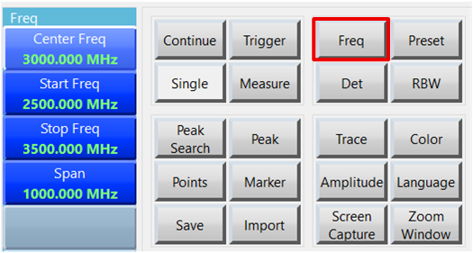
Figure Menu function​18

Detection method
name | Introduction
Sampling and Detection | The instantaneous level value at the center of each signal collection unit is selected as the display data point.
Peak detection | Selecting the maximum value within each signal collection unit ensures that signals such as sine waves are presented with their true amplitude, which is the default detection method for most instruments.
Negative peak detection | Selecting the minimum value within each signal collection unit is often used to distinguish between pulse signals and continuous wave signals or to identify specific signals.
Average detection | The average of all data values collected in each signal collection unit (usually power or voltage average) is applied, which is suitable for power measurement of noise-like signals or channel power assessment.

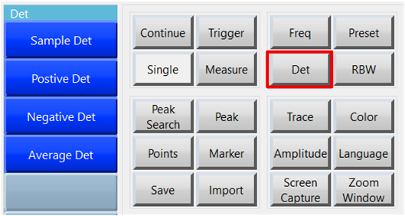
Figure Menu function​19

Reset
Clicking the "Reset" button initializes the host computer settings, which is suitable for situations where too many functions need to be turned off at once.

RBW
RBW (Resolution Bandwidth ) is one of the most important parameters in a spectrum analyzer, used to define the bandwidth of the intermediate frequency filter.
It determines the spectrum analyzer's ability to distinguish adjacent signals, as well as key performance indicators such as noise floor, scan speed, and dynamic range. Users can switch between these parameters with a single click using the [RBW] button, or enable Auto mode to allow the instrument to automatically couple and select the optimal value according to their actual measurement needs.
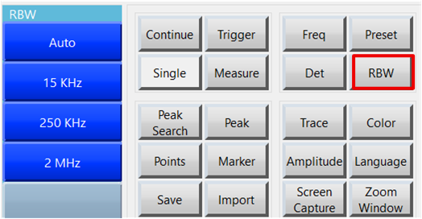
Figure Menu function​20

mark
Markers are one of the most frequently used and important functions on a spectrum analyzer, used to accurately read the frequency and amplitude at any point on the spectrum. The functions of each menu option are as follows:
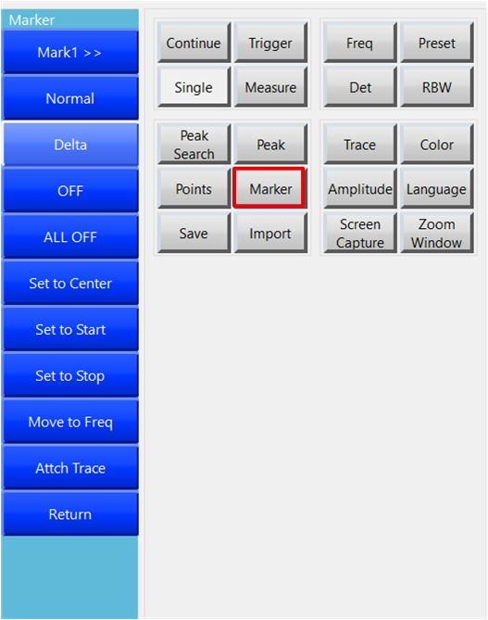
Figure Menu function​21

Select tag
Clicking this will take you to the submenu "Select Markers". The current software version supports selecting up to 10 marker points.

conventional
After clicking, the selected marker changes to the normal mode, as shown in the inverted triangle icon in Figure 3-9, with the text record number "2" at the top. The color of the marker point depends on the color of the currently selected associated trace. For the selectable attached trace function, please refer to the summary in 3.7.10.
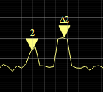
Figure Menu function​22

Difference
After clicking, the selected marker changes to difference mode, as shown by the icon on the right of Figure 3-9, numbered "Δ2". The color of the marker point depends on the color of the currently selected associated trace. For the "Attach to Trace" function, please refer to the summary in 3.7.10.

closure
Clicking this button will immediately close the currently selected marker.

Close all
Clicking this will immediately turn off all markers.

Set as center frequency
Clicking this will set the frequency of the currently selected marker to the center frequency of the spectrum.

Set as starting frequency
Clicking this will set the frequency of the currently selected marker to the starting frequency of the spectrum graph.

Set to stop frequency
Clicking this will set the frequency of the currently selected marker as the end frequency of the spectrum.

Set frequency
After clicking, an input box will appear at the top, where you can freely set the frequency of the currently selected marker point.

Related traces
This software supports displaying multiple commonly used traces and up to 10 reference traces simultaneously. To expand the functionality and image visibility of the markers, the traces associated with each marker point can be set, and the color of the marker point will change according to the color of the associated trace. The marker will be automatically enabled when the selected associated trace is not currently active. As shown in Figure 3-10, when the associated trace is set to "Maximum Preservation Trace," the marker color changes to red.
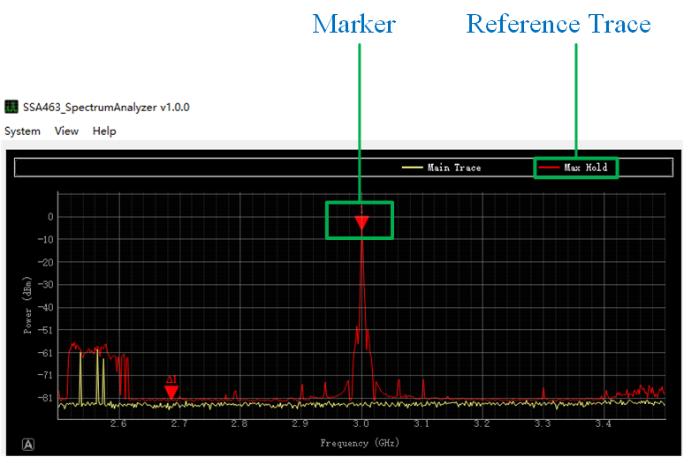
Figure Menu function​23

Peak Search
As shown in Figure 3-11, the commonly used functions of the marker point are all concentrated here.
Button Name | Function
Continuous peak | After clicking, the frequency of the selected marker will be set to the peak value of the spectrogram each time the frame is refreshed.
peak | After clicking, the frequency of the selected marker will be set as the peak value of the spectrum.
Next peak | Clicking will set the frequency of the selected marker as the next peak in the spectrum.
Next left peak | After clicking, the frequency of the selected marker will be set as the next left-hand peak in the spectrum.
Next right peak | After clicking, the frequency of the selected marker will be set as the next right-hand peak of the spectrum.
Minimum peak threshold | After clicking, an input box will pop up, allowing you to set the threshold for peak search. Peaks below this value will not be selected.
Minimum peak significance | After clicking, an input box will pop up, allowing you to set the minimum relative interval for the next peak. Peaks with a difference lower than this value will not be selected.

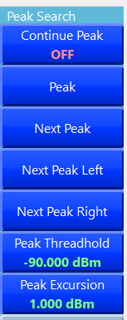
Figure Menu function​24

peak
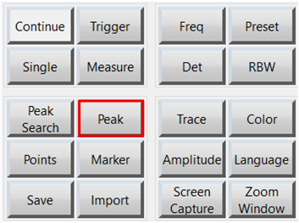
Figure Menu function​25
This button is a shortcut function. Clicking it will set the frequency of the selected marker to the peak value of the spectrum. If the currently selected marker is in the off state, it will be set to normal mode first.

Scan points
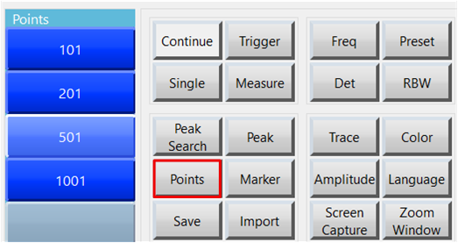
Figure Menu function​26
Set the number of points to be drawn in the final spectrogram.
Figure 3-14 shows the effect of setting the number of points to [101], and Figure 3-15 shows the effect of setting the number of points to [201].
Figure 3-16 shows the effect of setting the number of points to [501], and Figure 3-17 shows the effect of setting the number of points to [1001].

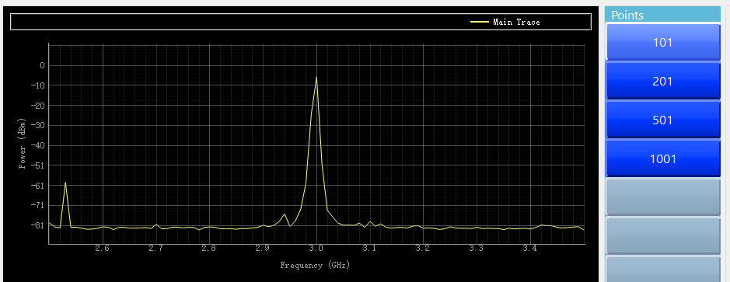
Figure Menu function​27
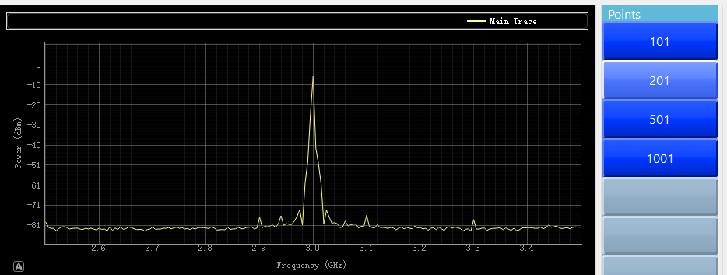
Figure Menu function​28
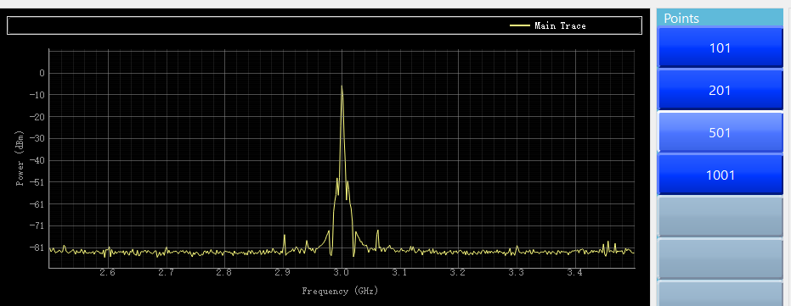
Figure Menu function​29

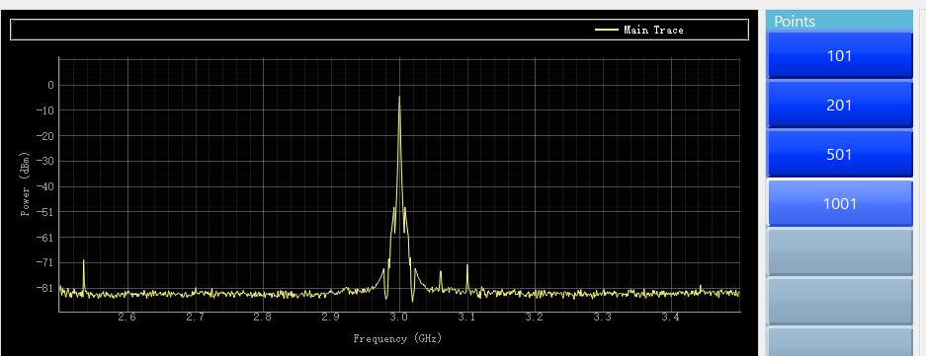
Figure Menu function​30

Data export
Used to save the image displayed in the current drawing interface. You can select one or multiple traces to save. The save path is the current software directory, and the file name format is "hours, minutes, seconds" + "trace name". Currently, only CSV format files are supported. Click OK to save. If saving traces is not enabled, the main trace or real-time transmitted trace data will be saved by default.
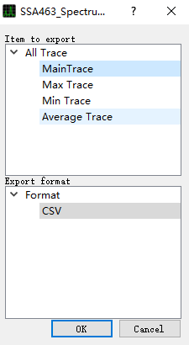
Figure Menu function​31

Data import
This tool is used to import saved data files. Clicking it will bring up a file selection box where you can choose a file to import.
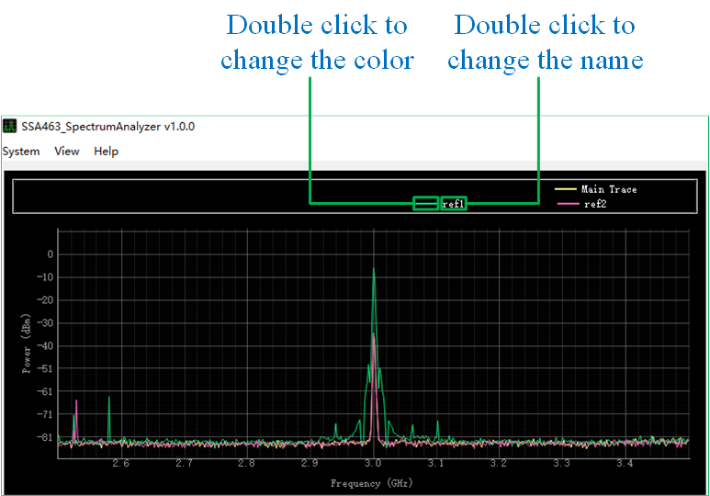
Figure Menu function​32
After importing the data, a legend will be displayed in the top information bar. The default name is "ref + sequence number". Double-clicking the "Name" section of the legend allows you to change the trace name, and double-clicking the "Color" section allows you to change the color. Under the menu "Markers" --> "Associate Traces" --> "Reference Traces", you can select to attach marker points to imported reference traces.
Note: If the number of points and frequency of the imported traces differ from the current software settings, the software will automatically adjust them to match the frequency and number of points of the imported traces. If the frequency and number of points differ from those of previously imported traces, the previously imported reference traces will be cleared.

trace
Trace type | Function
Main track | Real-time display of traces acquired and processed in real time
Maximum persistence trace | Retain the maximum value that has appeared in the history of the main trace; the trace only rises and never falls → Capture intermittent signals, short bursts, the worst spurious emissions, and EMI pre-scan to find the maximum radiation point; recording will be reset when closed.
Minimum Preservation Trace | Retain the historical minimum value of the main trace; the trace only decreases and never increases → Observe changes in noise floor, find the lowest signal level, and verify stability. Recording will be reset when closed.
Average trace | Power averaging of multiple frequency sweep results reduces noise, stabilizes measurement results, and provides phase noise traces. This method is recommended for formal test reports. The submenu allows selection of the smoothing method and the number of averaging iterations. See summary 3.14.1 for more details.
Smoothing function | The main trace is processed using a three-point smoothing algorithm, and multiple windowing methods can be selected.
Reference trace | Clicking this will toggle the menu, allowing you to choose whether to enable or disable reference trace display. See summary 3.14.3.
Clear reference traces | Clear currently imported traces
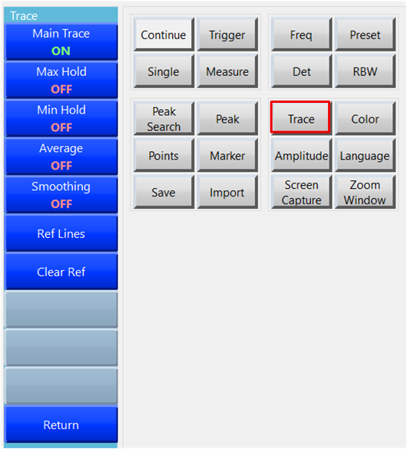
Figure Menu function​33

Average trace
Click the "Average Trajectory" button in Figure 3-20, as shown in Figure 3-21. The button functions are as follows:
- Switch the averaging trace enable status. When enabled, the text "Averaging Enabled" is highlighted in green, and when disabled, the text "Averaging Disabled" is highlighted in red.
- Click to select the averaging method. Currently, only sliding average is supported. More options will be available in future updates. The averaging method will be highlighted on the second line of the button.
- After clicking, an input box will appear in the top information bar, where you can modify the average number of times. The current average number of times is displayed in green highlighted text on the second line of the button.
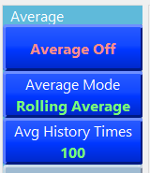
Figure Menu function​34

Smoothing function
Click the "Smoothing Function" button in Figure 3-21 to bring up a selection box where you can choose the smoothing algorithm and windowing method. Clicking the "OK" option below enables the smoothing function, while clicking it disables it.
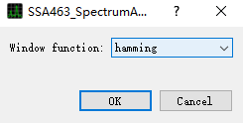
Figure Menu function​35

Reference trace
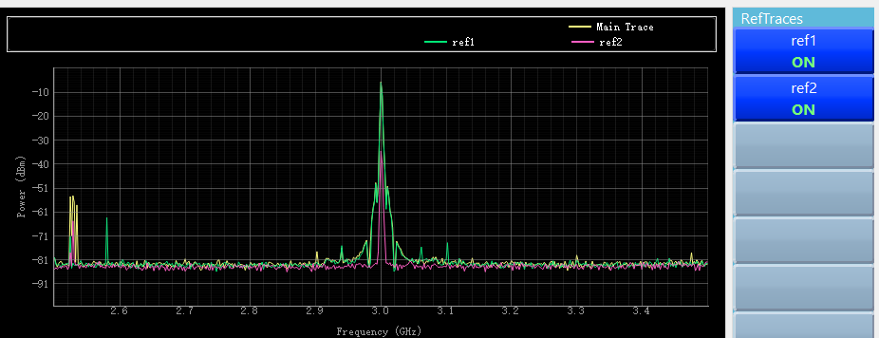
Figure Menu function​36

color
Clicking the "Color" button will bring up a color selection box, allowing you to modify the color of all supported traces.
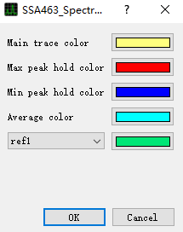
Figure Menu function​37

amplitude
name | Function Description
Reference level | Set the scale value at the top of the spectrum graph.
attenuation | Control the front-end variable attenuator (0–30 dB) to adapt to signals of different strengths.
Y-axis scale | Set the relative interval of the spectrum region scale.
Y-axis upper limit | Set the Y-axis of the spectrum graph area to display maximum and minimum values.
Y-axis lower limit | Set the minimum value displayed on the Y-axis of the spectrum graph area.
Y-axis units | Set the Y-axis unit; options include dBm, dBV, dBmV, and dBuV.
Logarithmic X-axis | Set the X-axis as a logarithmic axis.

Y-axis units
0 dBm ≈ -13 dBV ≈ 48.75 dBmV ≈ 107 dBμV (50 Ω system)
0 dBV ≈ +13 dBm
0 dBmV ≈ -48.75 dBm
0 dBμV ≈ -107 dBm

language
Click the "Language" menu to switch the system language. This software supports both Chinese and English.
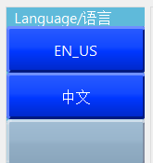
Figure Menu function​38

screenshot
Clicking the "Screenshot" button on the right will bring up a screenshot prompt box, allowing you to select one or more of the four parts. The screenshot content for each option is shown below.

The whole scene
The captured image is shown in Figure 3-26.
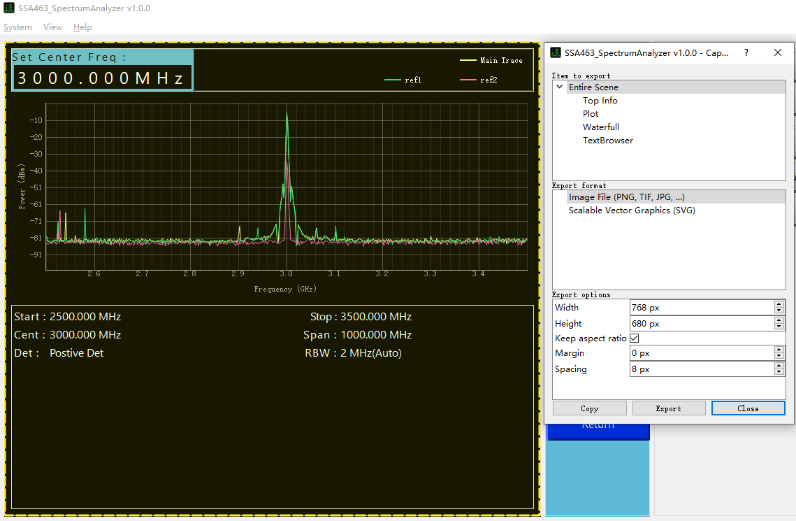
Figure Menu function​39

Top Information
The cropped area is shown in Figure 3-27.
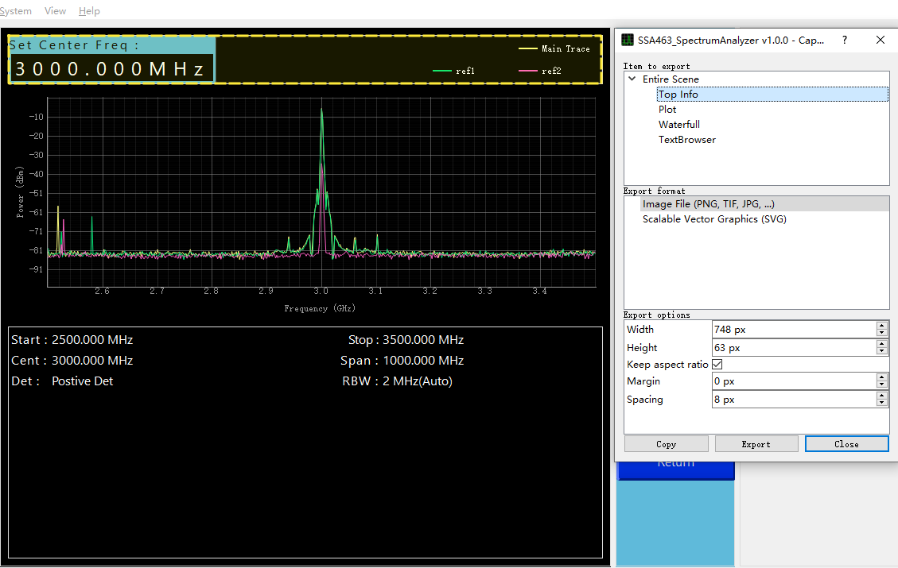
Figure Menu function​40

Spectrum
The selected region is shown in Figure 3-28.
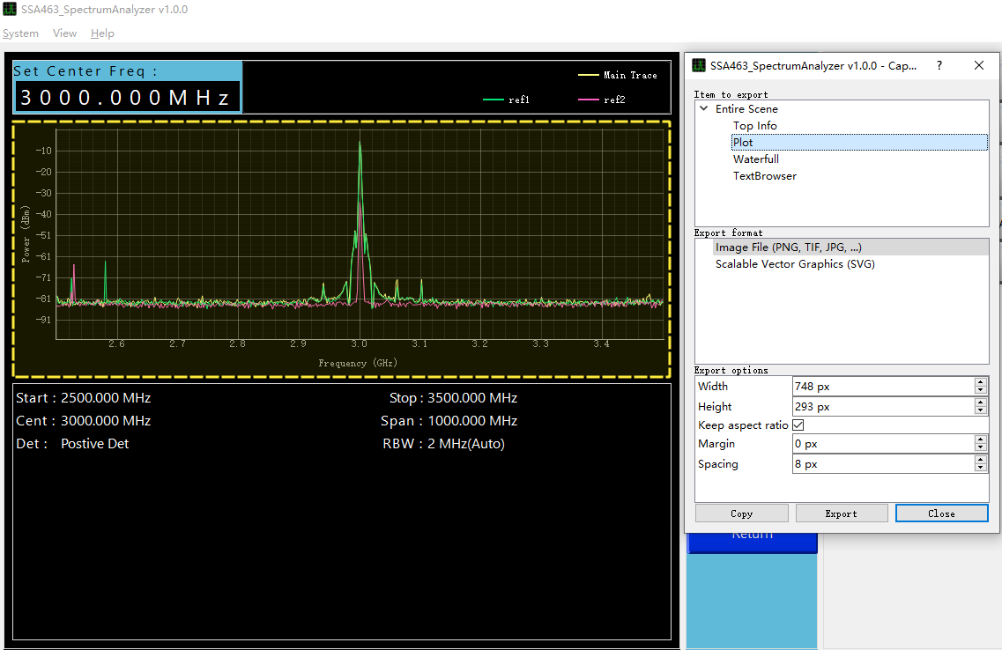
Figure Menu function​41

Waterfall picture
The cropped area is shown in Figure 3-29.
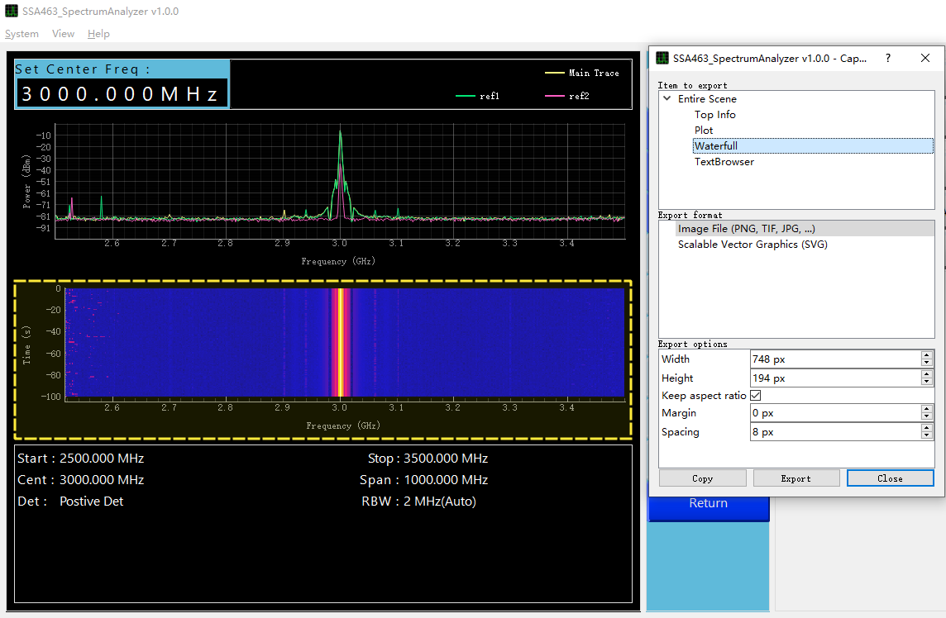
Figure Menu function​42

Text information area
The cropped area is shown in Figure 3-30.
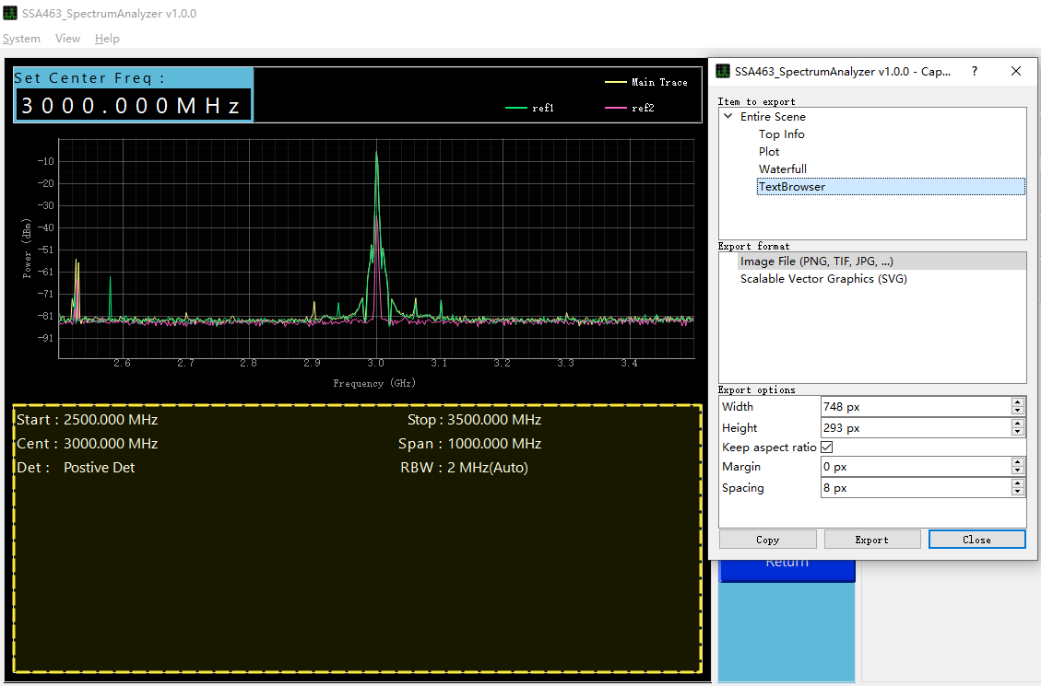
Figure Menu function​43

Screenshot export format
It supports common image formats such as PNG, JPG, BMP, TIFF, and SVG. Among them, SVG format can be scaled infinitely without loss of quality and has a small file size , making it suitable for long-term use or storage.

Resize window
After clicking "Zoom Window", the button will be highlighted in yellow as shown in Figure 3-31. At this time, you can use the rectangular selection box to select the spectrum area (if you accidentally click it, you can click again to cancel). After the selection is completed, an additional window will be generated to draw all the traces of the selected area simultaneously, as shown in Figure 3-31.
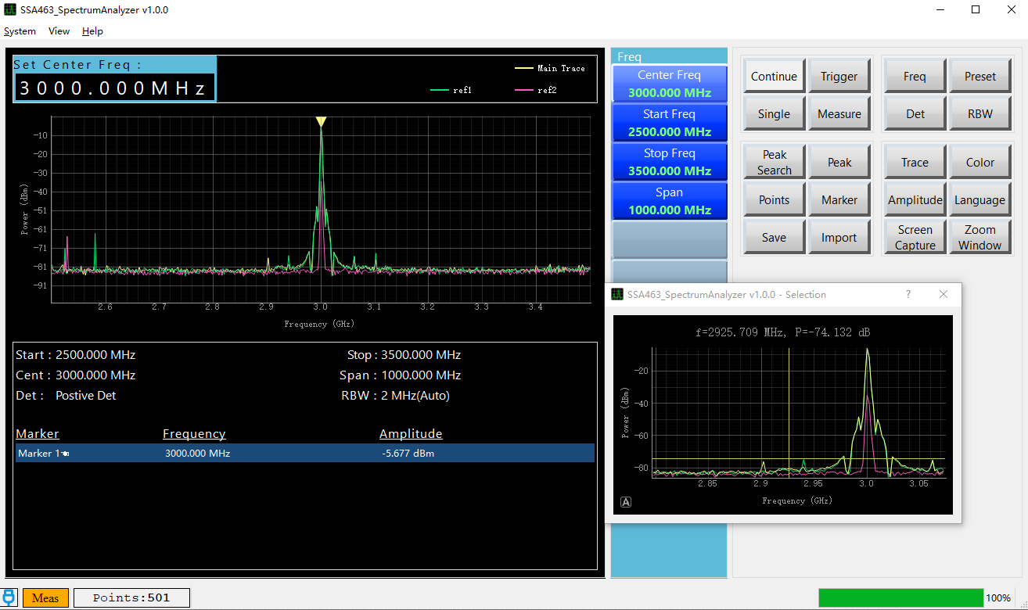
Figure Menu function​44

Quick Use

Run the software
Download SSA463_SpectrumAnalyzer v1.0.0.exe, double-click to run it. The software's default startup interface is shown in Figure 4-1.
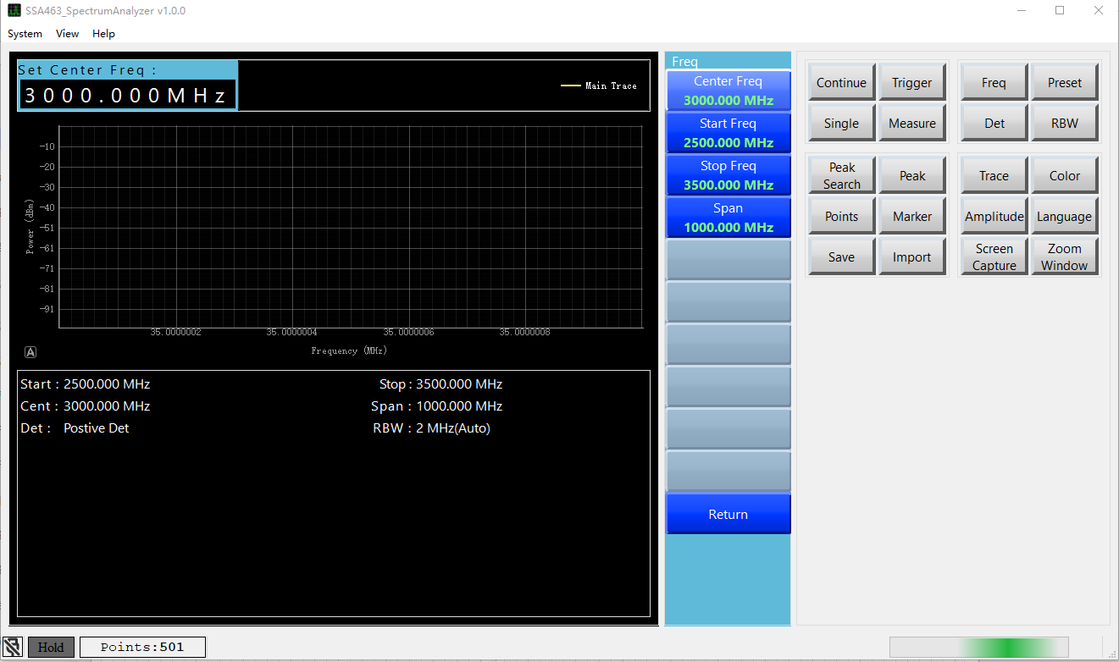
Figure Quick Use​45

Connecting devices
Click "System" in the status bar at the top of the software --> "Connect Device". After a successful connection, as shown in Figure 4-3, the software will start a loop scan by default, and the status bar will display "Connected".
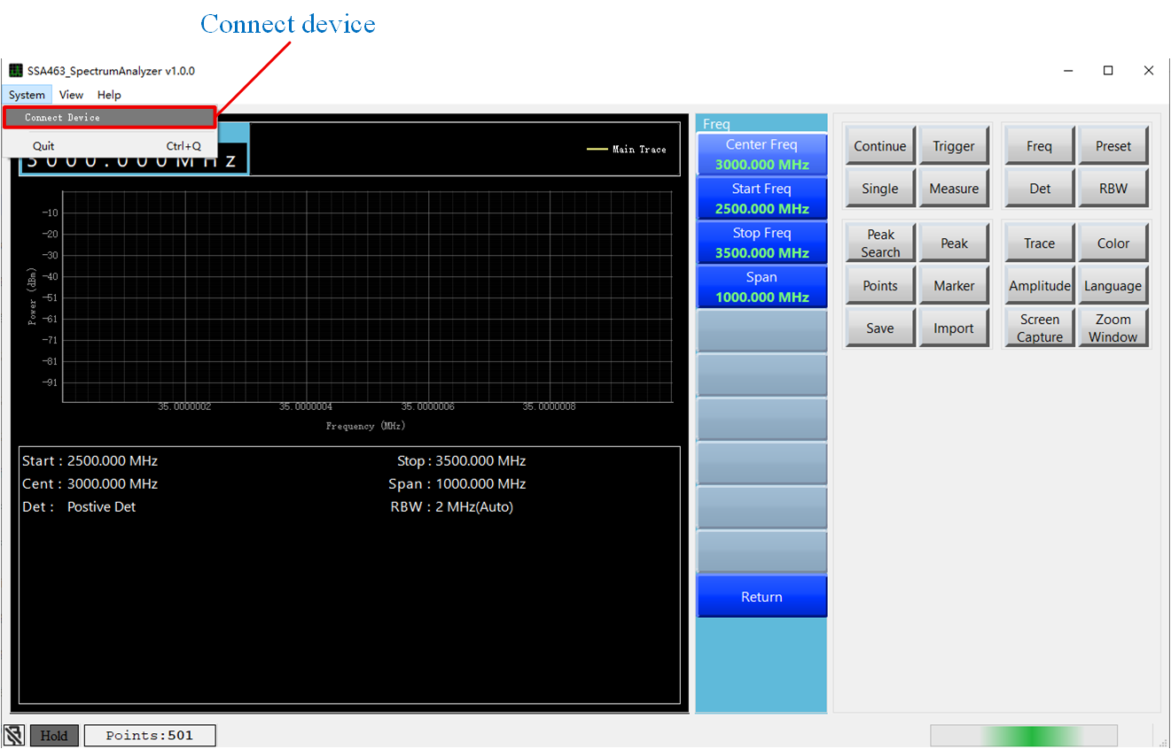
Figure Quick Use​46
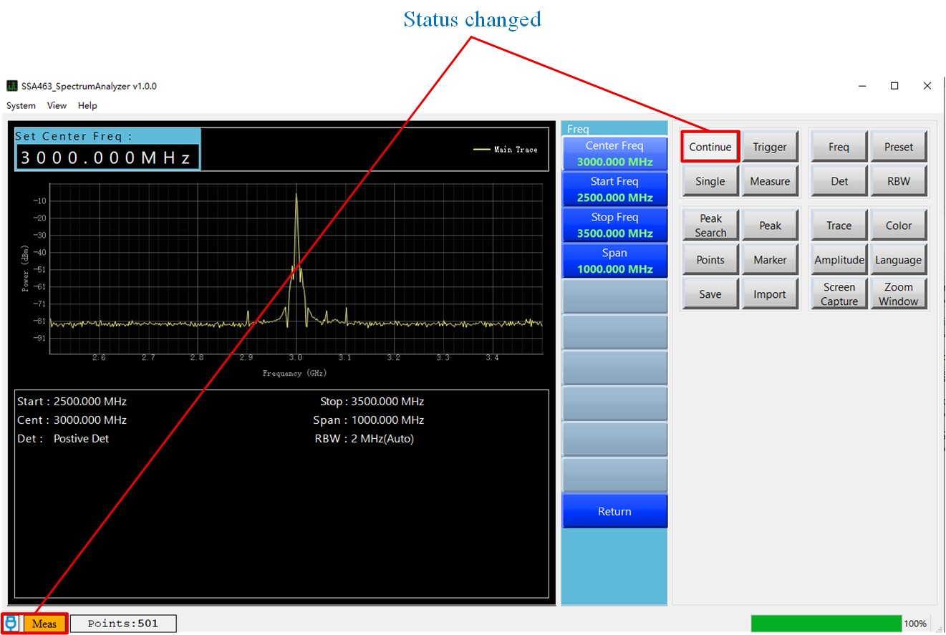Figure Quick Use​47

Connection failed
The following failure scenarios may occur during the connection process, as shown in Figure 4-4. Please ensure that...
- The SSA463 device has been connected to the computer host via USB data cable.
- The device has been updated to the latest version.
- The device was not opened in the local serial port assistant program.
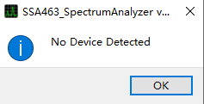
Figure Quick Use​48

Set frequency
- Click the "Frequency" menu and set the start and end frequencies or center frequency as needed. The frequency range is [35MHz - 6.3GHz].
- Use the keyboard to directly input the frequency; there's no need to click the input box. Note: The default unit in the input box is Hz. You can enter the characters "H", "K", "M", or "G" to represent the unit, regardless of case. These represent Hz, kHz, MHz, and GHz, respectively. Once you enter the unit or press the Enter key, the input is complete, and the software will apply the changes.
- Assuming the center frequency is set to 2GHz and the sweep width to 1GHz, the spectrum diagram answering interface should look like Figure 4-5.
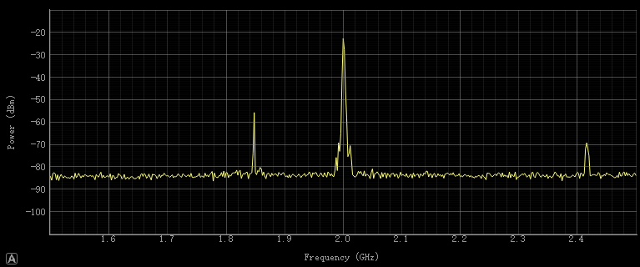
Figure Quick Use​49

Set the detection method
Click the "Detection Mode" menu, select the detection mode you want to change, and the change will take effect immediately.
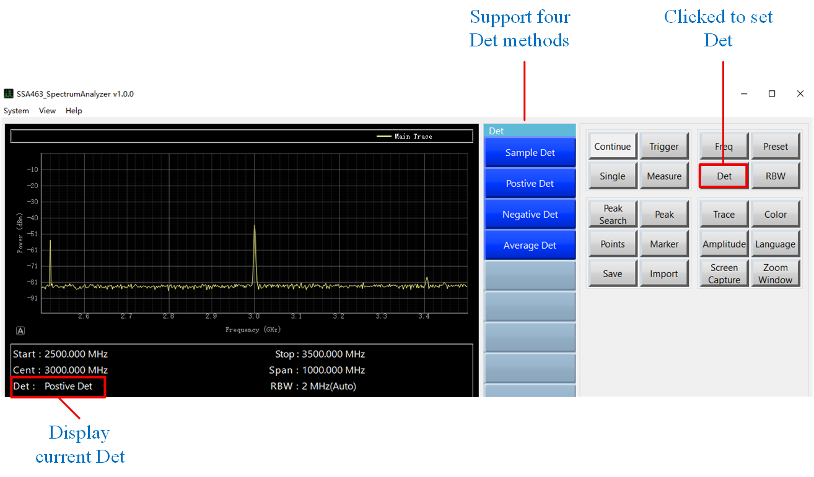
Figure Quick Use​50

Set RBW
RBW defaults to automatic mode, which means that when the frequency, number of points, or detection method is modified, it will automatically switch to the optimal setting, and the change will take effect immediately.
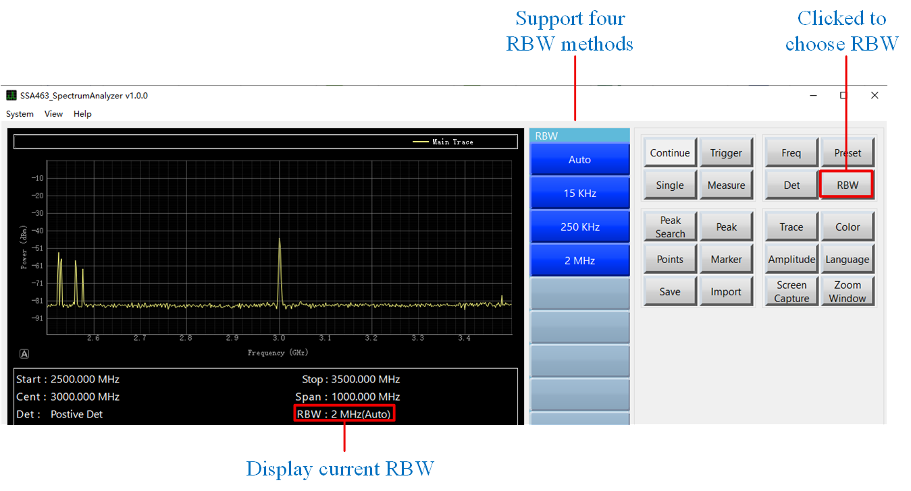
Figure Quick Use​51

Set points
Click the "Scan Points" menu, select the number of scan points you want to set, and the change will take effect immediately. The status bar below will display the current number of scan points in real time.

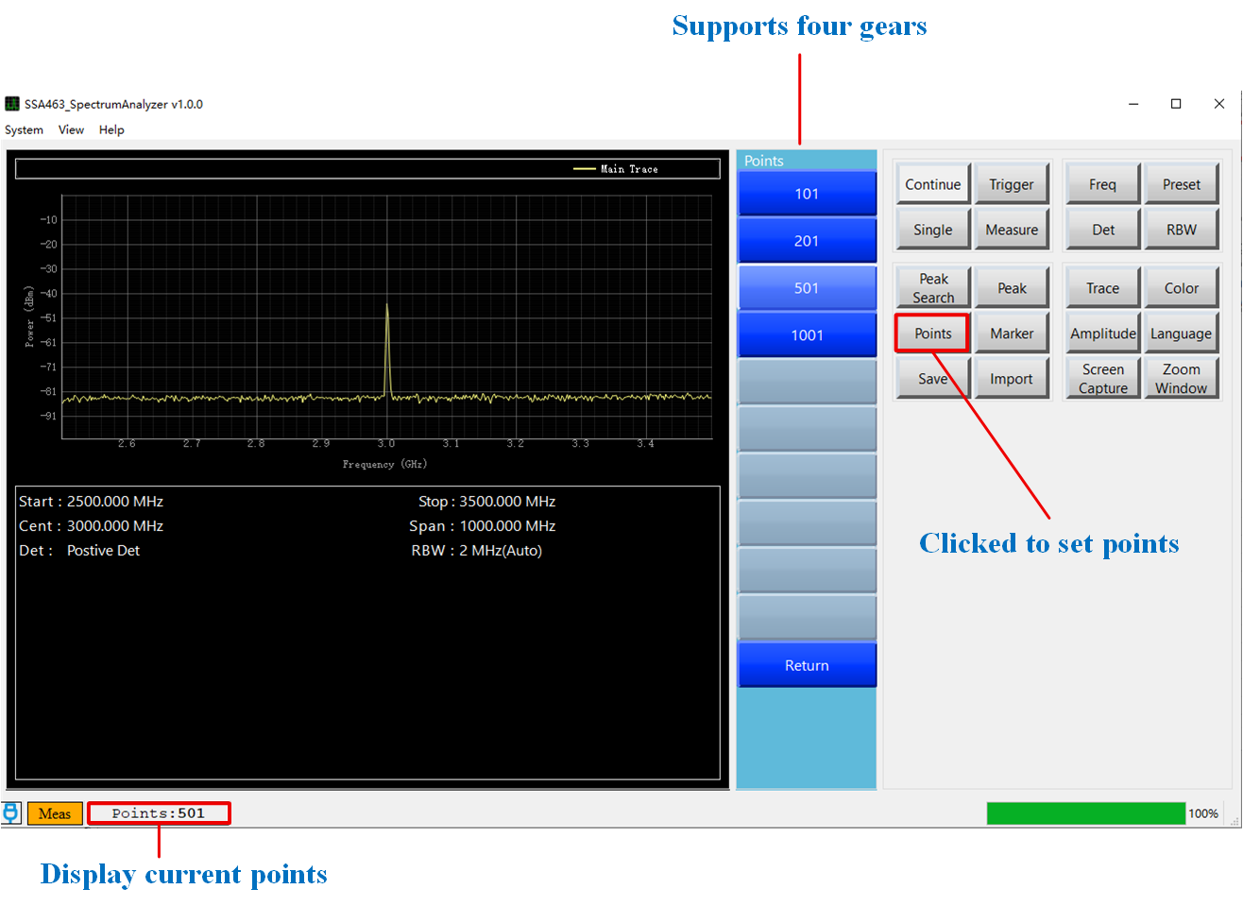
Figure Quick Use​52

Use tags
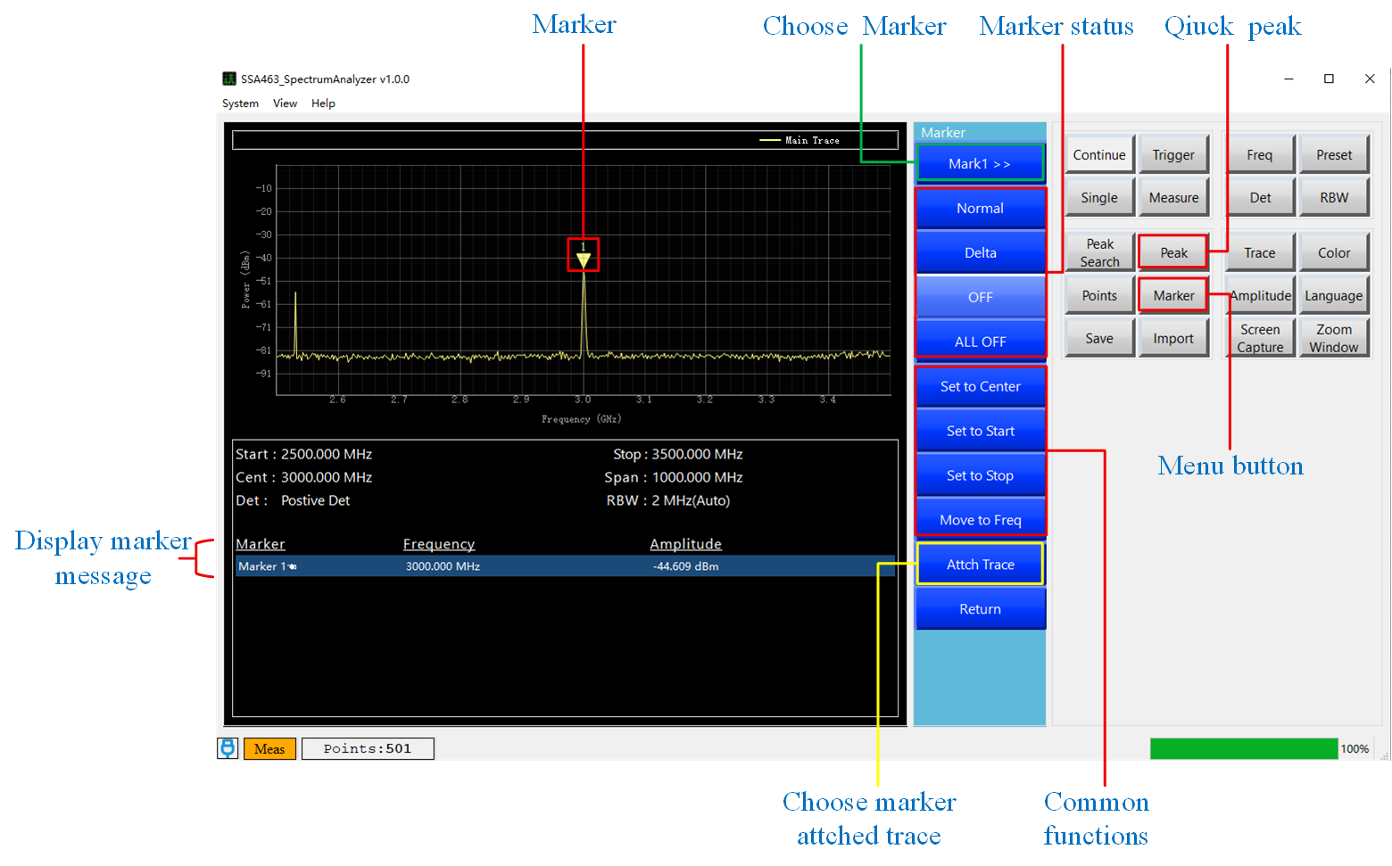
Figure Quick Use​53

Enable marking
Enter the "Marker" menu, click "Select Marker" to choose the desired marker, and then click the relevant options for "Marker Status" to turn the marker on or off. The information bar below displays information for all marker points; when enabled, an inverted triangle marker will be visible in the spectrum. Click the "Peak" button to quickly enable the marker.

Function
The "Common Markup Functions" option is shown in Figure 4-9.
- "Set as center frequency": Sets the frequency of the currently selected marker as the center frequency of the spectrum. This marker is unavailable when the screen is off.
- "Set as starting frequency": Sets the frequency of the currently selected marker as the starting frequency of the spectrum. The marker is not available when the screen is off.
- "Set as End Frequency": Sets the frequency of the currently selected marker as the end frequency of the spectrum. The marker is unavailable when the screen is off.

Related traces
This software supports the simultaneous display of multiple base traces and up to 10 reference traces (reference traces can be imported via the "Data Import" button). To prevent display errors, this software supports attaching markers to different traces. Clicking "Select Marker Associated Traces" in Figure 52 will take you to the interface shown in Figure 4-10. Clicking the button in the figure allows you to change the marker's associated trace; the changes take effect immediately. This change applies to all markers. The currently associated trace will be highlighted.
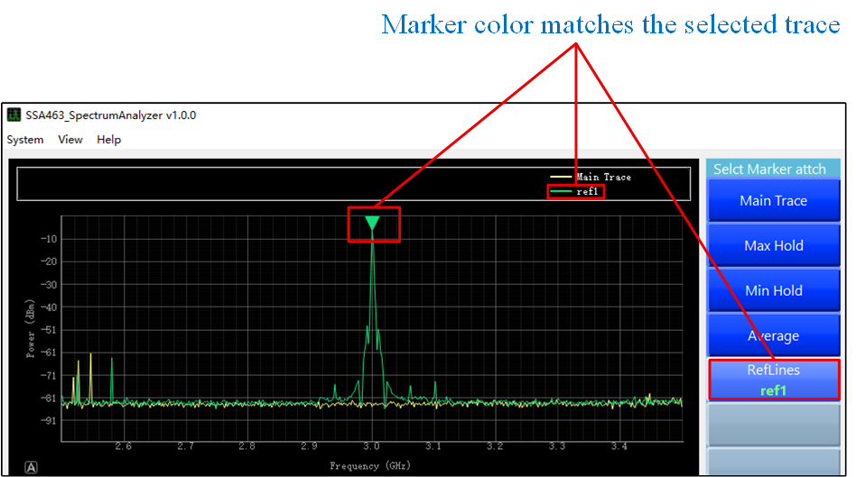
Figure Quick Use​54

Peak Search
Clicking the "Peak Search" menu will display a list of specific functions.
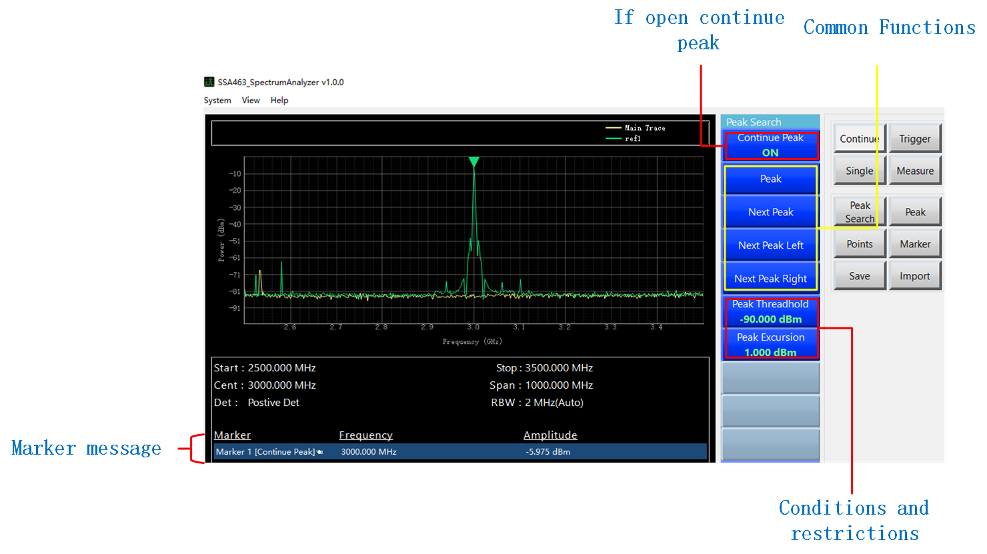Figure Quick Use​55

Continuous peak
The "Continuous Peaks" button automatically updates the currently selected marker to the peak values of the spectrum after the spectrum is refreshed. The button is marked with a green "ON" sign, indicating that the function is enabled. The marker name in the "Marker Information" section below Figure 4-12 will also have a prompt word added after this function is enabled. Clicking the button will switch the state. When the button is off, a red "OFF" sign will be displayed below it.

Common functions
As shown in Figure 54, the buttons in the "Common Peak Functions" section...
- Peak: Clicking this button moves the currently selected marker to the peak of the spectrum.
- Next Peak: Clicking this will move the currently selected marker to the next peak in the spectrogram.
- Next Left Peak: Clicking this will move the currently selected marker to the next left peak in the spectrum.
- Next right peak: Clicking this will move the currently selected marker to the next right peak in the spectrum.

Set additional conditions for peak values
As shown in Figure 54, the buttons in the "Peak Condition Limitation" section...
- Minimum peak threshold: After clicking, an input box will appear above the spectrum graph, where you can set the minimum peak threshold. Peaks below this value will not be located.
- Minimum Peak Significance: After clicking, an input box will appear above the spectrum, where you can set the minimum peak significance value. When searching for peaks, the next peak with a difference lower than this value will not be located.

Level trigger
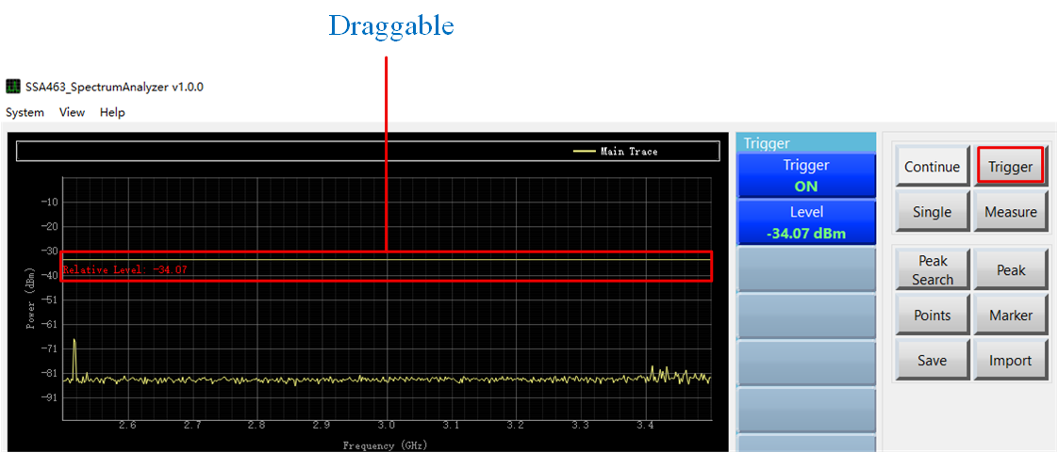
Figure Quick Use​56
After clicking the "Trigger" menu, as shown in Figure 4-12, the button indicated by the "Status Indicator" shows whether triggering is enabled. When the triggering function is enabled, the button is highlighted in green as "ON," and when disabled, it is highlighted in red as "OFF." When enabled, a horizontal reference line will be displayed on the spectrum. The relative amplitude of the horizontal line can be set by pressing the "Trigger Reference Value" button, or by dragging the reference line on the spectrum for quick setting.

Measurement
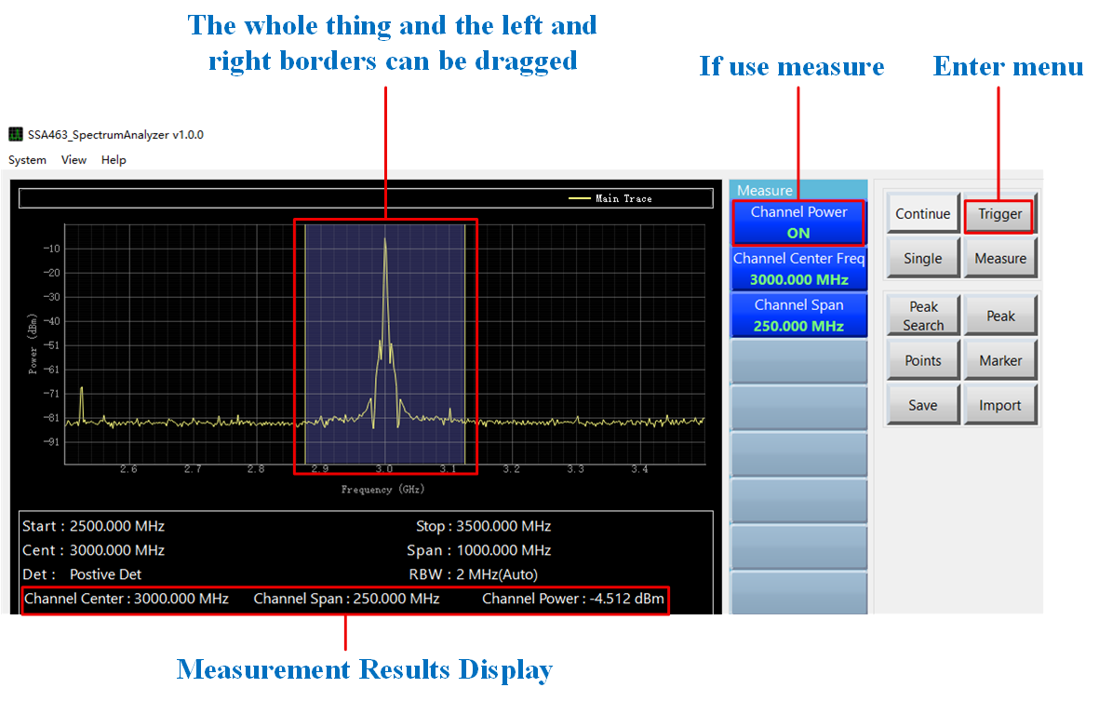
Figure Quick Use​57

Turn on or off
Click "Measurement" --> "Channel Power" in Figure 4-13 to turn the measurement function on or off. When on, the button will display a green "ON" sign; when off, the button will display a red "OFF" sign.

Change range
As shown in Figure 55, the highlighted purple area in the spectrum represents the power measurement range. To change the range, there are two methods.
- Drag the highlighted area directly, or stretch it to the left or right.
- Click the "Channel Center Frequency" or "Channel Sweep" button in the image and modify it through the pop-up input box.

Results Display
As shown in Figure 4-13, the measurement results and key parameters will be displayed in the information bar below. Clicking on this section will take you directly to the "Measurement" menu.

Use other traces
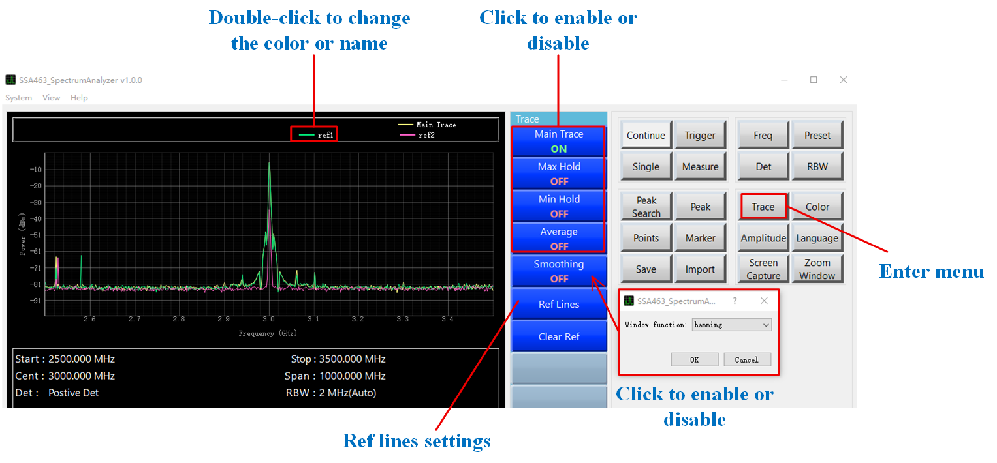
Figure Quick Use​58

Turn on or off
As shown in Figure 4-14, after clicking the "Trace" button to enter the menu, find the trace you want to enable and click it to switch its state. The enabled state is indicated by a green highlighted "ON" and the disabled state is indicated by a red highlighted "OFF". When you click "Smoothing Function", a prompt box will pop up, as shown in the lower right corner of Figure 4-14. You can select a window function, and then confirm or cancel to change the enabled state of "Smoothing Function".

Average trace
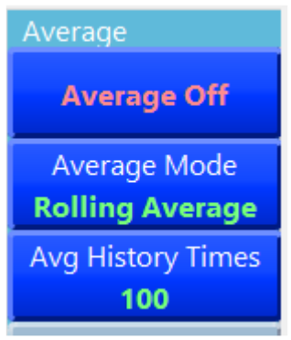
Figure Quick Use​59
Clicking on "Average Trajectory" in Figure 4-14 will bring up the menu shown in Figure 4-15, where the three buttons have the following functions:
- Enable or disable averaging. When enabled, the text "Averaging Enabled" is highlighted in green; when disabled, the text "Averaging Disabled" is highlighted in red. Click to toggle the status.
- The averaging method is displayed below the button. Clicking it allows you to select different averaging methods. Currently, only sliding average is supported.
- The average number of times is displayed below the button. Different average numbers may have different effects on the average result; click to set the value according to your needs.

Reference trace
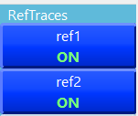
Figure Quick Use- 60
Clicking "Reference Trace" in Figure 57 will take you to the menu shown in Figure 59, where you can set whether the corresponding trace is visible. The color and name can be set in the legend section of Figure 57. Double-clicking the name section will change the name, and double-clicking the color section will change the color.

Clear reference traces
Clicking the "Clear Reference Traces" button in Figure 57 will clear the currently imported reference traces, which will also be deleted from the screen.

Color selection
Clicking on the colored section in Figure 4-17 will take you to the interface shown in Figure 4-18, where you can change the specific color of the trace. You can use the quick classic custom color scheme or directly set the specific RGB color value.

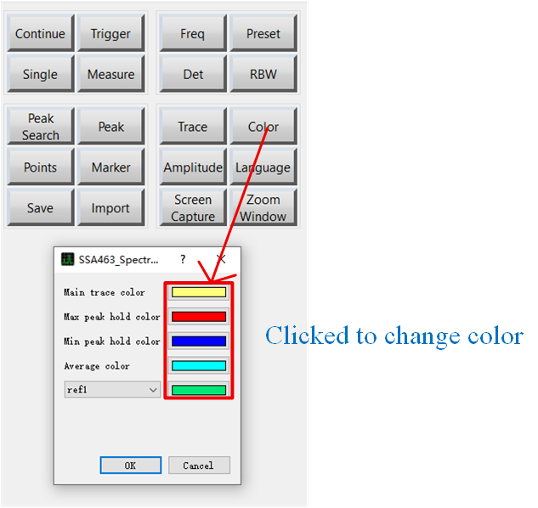
Figure Quick Use​61
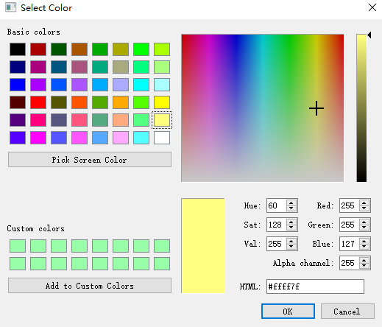
Figure Quick Use​62

amplitude
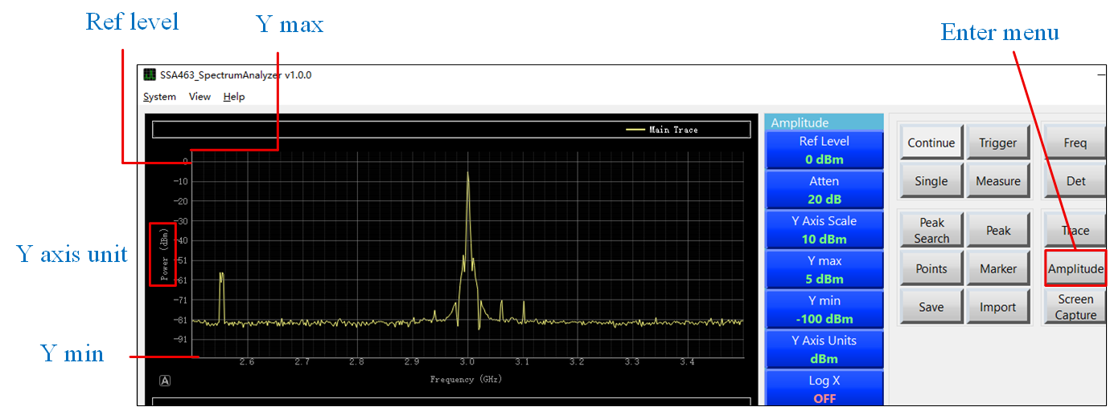
Figure Quick Use​63
As shown in Figure 4-19, click the "Amplitude" button to enter the menu.
- "Reference Level" represents the first tick value of the spectrum, and "Upper Y-axis Limit" represents the highest point on the Y-axis. When both parameter values are the same, the first tick mark and its text will be hidden. The lower Y-axis limit represents the minimum value on the Y-axis of the spectrum.
- Attenuation; changing this value configures the hardware settings of the spectrum analyzer's lower-level device.
- The Y-axis scale, as shown in Figure 4-19, represents the difference between two scale divisions, with an accuracy of 1.
- The Y-axis unit will change the system's real-time calculation method after being changed, so choose carefully (the maximum and minimum will remain unchanged). The available units are shown in Figure 4-20. Click "Y-axis Unit" in Figure 4-19 to enter.
• 0 dBm ≈ -13 dBV ≈ 48.75 dBmV ≈ 107 dBμV ( 50 Ω system)
· 0 dBV ≈ +13 dBm
• 0 dBmV ≈ -48.75 dBm
· 0 dBμV ≈ -107 dBm
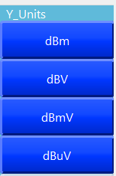
Figure Quick Use​64

Data import
When using this function, ensure that the imported file is a file saved by this software; otherwise, unexpected problems may occur.

Data export
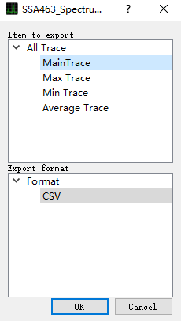
Figure Quick Use​65
Clicking the "Export Data" button in Figure 4-21 will bring up a dialog box. You can export all traces at once or a single trace. Currently, only .csv format is supported, but more formats will be added in the future. After confirming the export, a pop-up prompt as shown in Figure 65 will appear. The save file location is the current software directory, and the file name is "Hour Minute Second" + "Underline" + "Trace Name".
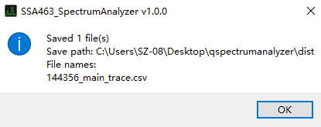
Figure Quick Use​66
Note that if exporting is not enabled for a particular trace, the main trace data will be exported by default, which means the data will be received in real time or from the previous frame.

Switch language
Click the "Language" button in Figure 4-23 to enter the language switching menu. Currently, only Chinese and English menus are supported.
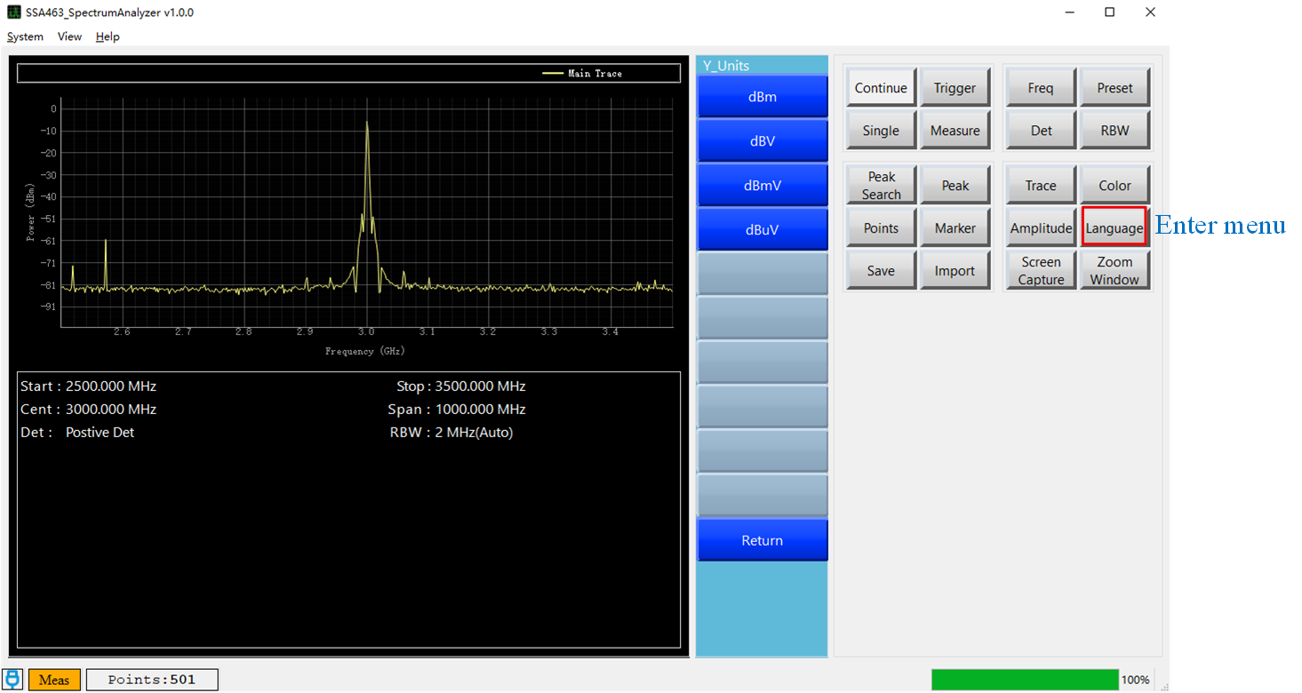
Figure Quick Use​67
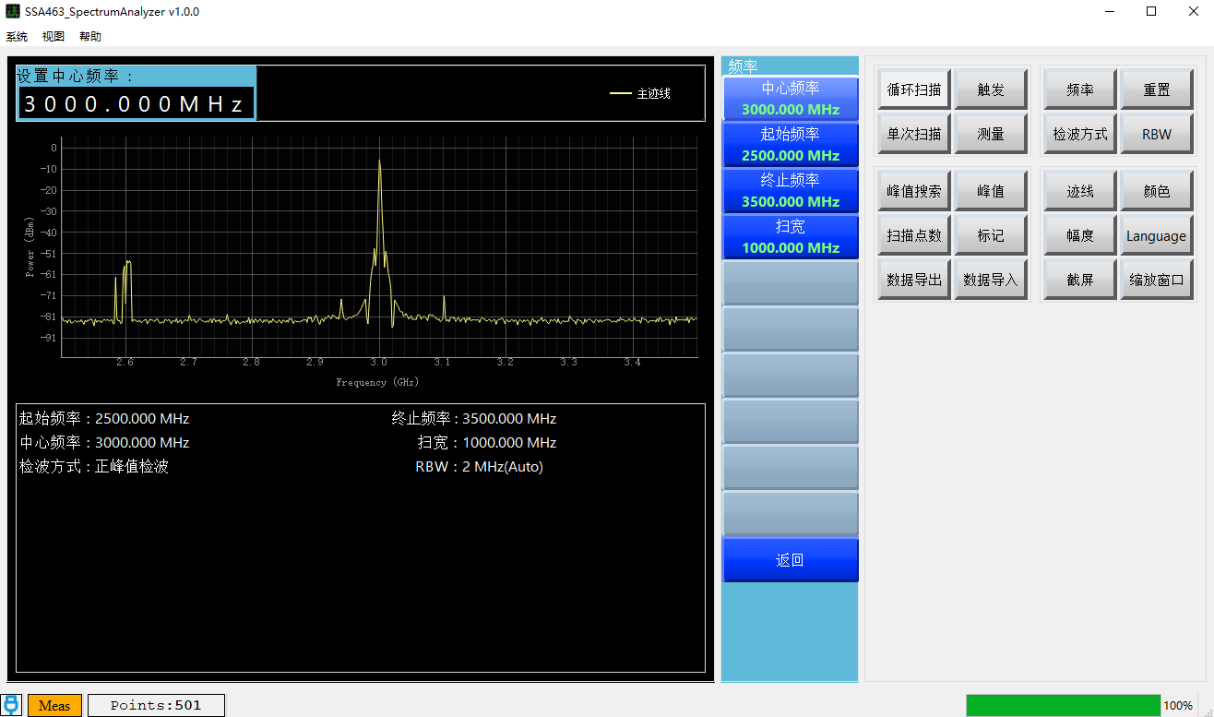
Figure Quick Use- 68

